Student Grade Calculator Documentation
1. Project Overview and Objectives
Overview
The Student Grade Calculator is a Python-based application that calculates a student's grade based on the marks entered by the user. The program validates user input, assigns grades according to predefined rules, and displays encouraging feedback messages.
Objectives
- Accept student name and marks as input.
- Calculate grades automatically.
- Validate marks to ensure they are between 0 and 100.
- Handle invalid inputs using loops and exception handling.
- Display motivational messages for each grade.
- Demonstrate the use of Python functions, conditions, and loops.

2. Setup and Installation Instructions
Requirements
- Python 3.x installed on your computer.
Installation Steps
- Download or clone the project repository.
- Open the project folder.
- Open Terminal or Command Prompt.
- Run the program using:
python grade_calculator.py
- Enter the student name and marks when prompted.

3. Code Structure Explanation
File Structure
Student-Grade-Calculator/
│
├── README.md
├── grade_calculator.py
├── test_cases.txt
└── screenshots/
Main Components
Input Section
Collects student name and marks.
student_name = input("Enter student name: ")
Validation Section
Ensures marks are between 0 and 100.
while True:
Function Section
Calculates grade and returns a message.
def calculate_grade(marks):
Output Section
Displays final result to the user.
print("Grade:", grade)

4. Screenshots of Working Application
Include screenshots in the screenshots folder:
Screenshot 1
Valid Input Example
Enter student name: Priya
Enter marks (0-100): 85

RESULT FOR PRIYA
Marks: 85/100
Grade: B
Message: Very Good! Keep it up!
Screenshot 2
Invalid Marks Example
Enter marks (0-100): 120
Marks must be between 0 and 100
Screenshot 3
Invalid Character Input
Enter marks (0-100): abc
Invalid input. Please enter numbers only.

5. Technical Requirements Fulfilled
Requirement | Implementation
if-elif-else Statements | Used for grade determination
Input Validation | Marks checked between 0 and 100
Function | calculate_grade() function created
Encouraging Messages | Added for every grade
While Loop | Repeats until valid input is entered
Exception Handling | try-except used for invalid input
Testing | Multiple test cases executed
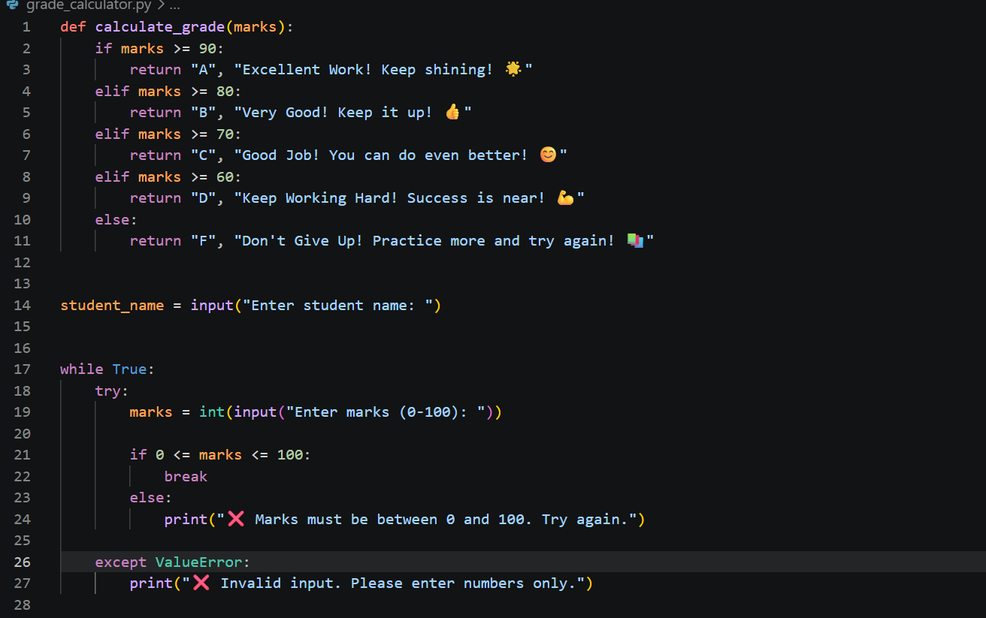
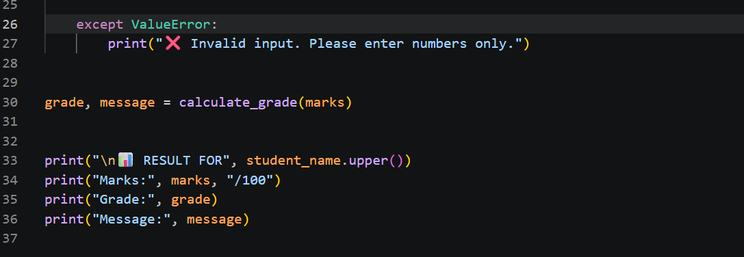

Output:
